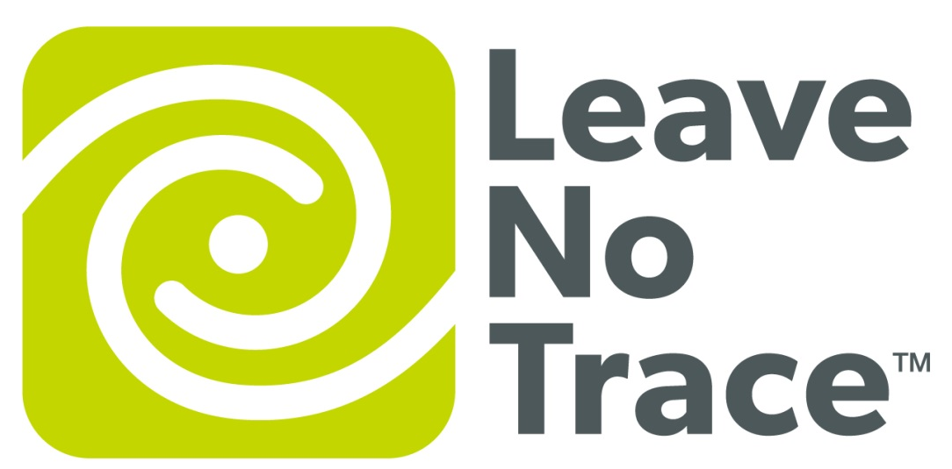

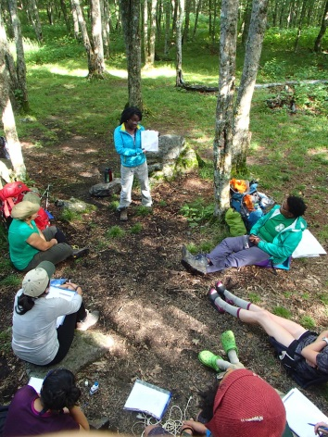
Trainer Course
June 9th and 10th, 2018

The Appalachian Trail Conservancy is offering a Leave No Trace Trainer Course in Southwest Virginia!

This two-day course will take place at the Mountain Shepherd Survival School in Catawba, VA. Participants will learn about the seven principles of Leave No Trace, and techniques for disseminating these low impact skills.
Trainer Courses are designed for educators, guides, volunteers, agency employees and other outdoor professionals. Successful graduates of the Trainer Course gain skills to teach Leave No Trace techniques and ethics to their clients, friends and family in a variety of settings - such as schools, camps, parks, wilderness and front country areas.

Space is limited! For more information contact Kathryn Herndon-Powell: kherndon@appalachiantrail.org or 540.904.4316
